The Assignment Presented By :



As we have a network consists of 8 workstations we should chose windows server 2008 enterprise edition 64 bit because , it supports 8 processors and up to 2TB of RAM
This edition supports also clusters of up to 8 nodes and Active Directory Federated Services (ADFS).

We will create active directory on the server (25 % of grade)

Steps of creation the active directory :
Form the list start we chose run icon and write (dcpromo) and press ok then it will show active directory installation wizard

We will chose create a new domain in a new forest

And add the domain name which is : costcoNewmarketPharmacy.com
The wizard will give us the domain NetBIOS name which is : CSTCONEWMARKET

The wizard give us the forest functional level and we will chose the windows 2000 because it provides all active directory for windows 2000 or up
And the domain functional level will be windows 2000 for the same reason

Then we chose from domain additional options : DNS server
Then we will assign a password for the administrator account that will be used when this domain controller is started in directory services restore mode
The wizard will restart the OS when it finished the installation

To create organization unit we will do this steps
From start menu then administrative tools active directory users and computers right click on the cstconewmarktpharmacy.com new organizational unit
Right click on organizational unit (manager) we will select new user and add the name of user which is Hank Richardson
The same way for the pharmacists and technicians

Server computer DC | Ip address : 192.168.1.2  Mask : 255.255.255.0  Dns : 192.168.1.2
Manager | Ip address : 192.168.1.3  Mask : 255.255.255.0  Dns : 192.168.1.2
Pharmacist 1 | Ip address : 192.168.1.4  Mask : 255.255.255.0  Dns : 192.168.1.2
Pharmacist 2 | Ip address : 192.168.1.5  Mask : 255.255.255.0  Dns : 192.168.1.2
Pharmacist 3 | Ip address : 192.168.1.6  Mask : 255.255.255.0  Dns : 192.168.1.2
Technician 1 | Ip address : 192.168.1.7  Mask : 255.255.255.0  Dns : 192.168.1.2
Technician 2 | Ip address : 192.168.1.8  Mask : 255.255.255.0  Dns : 192.168.1.2
Technician 3 | Ip address : 192.168.1.9  Mask : 255.255.255.0  Dns : 192.168.1.2
Technician 4 | Ip address : 192.168.1.10  Mask : 255.255.255.0  Dns : 192.168.1.2

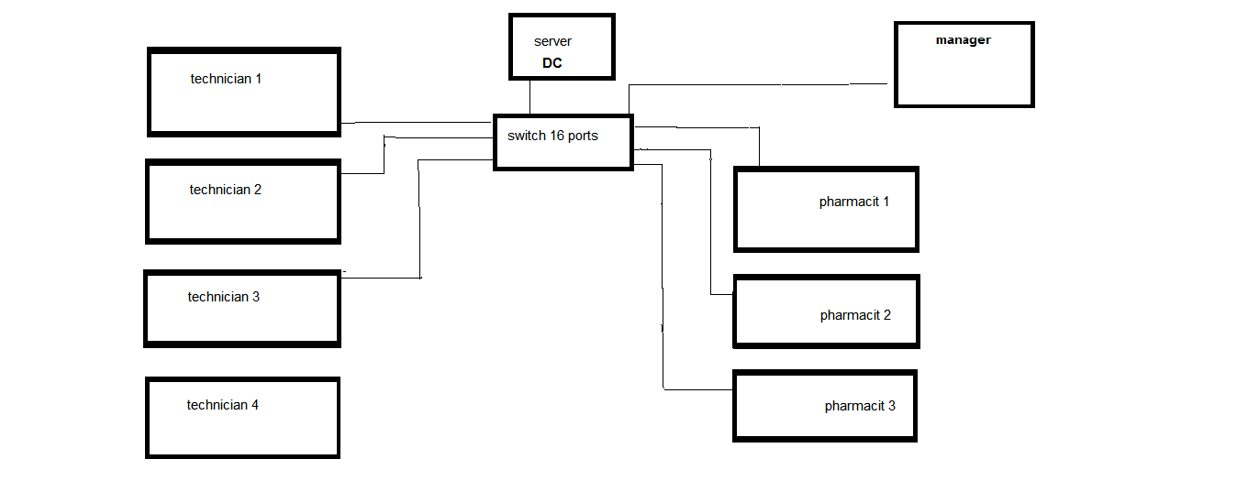
The schematic of our network : (15 % of grade)

Windows Server 2008 R2 is a multi-purpose server designed to increase the reliability and flexibility of your server or private cloud infrastructure, helping you to save time and reduce costs. It provides you with powerful tools to react to business needs faster than ever before with greater control and confidence
The latest release of Service Pack 1 (SP1) for Windows Server 2008 R2 delivers many improvements for you to implement a robust datacenter and desktop virtualization plan. Whether you want to consolidate servers, build a private cloud, or offer Virtual Desktop Infrastructure (VDI), the features of Windows Server 2008 R2 enable you to take your datacenter and desktop strategy to a new level.

As Microsoft says that Windows Server 2008 is the “most secure” server OS they have every created I will mention some of them (10 % of grade)
Active Directory Federation Service – allows administrators to easily set up trust relationships with federation partners.
Read-Only Domain Controllers - these domain controllers will be used in environments where you need a domain controller but you cannot guarantee the physical security of the server.
Server Core Installation - a new type of install of Windows Server 2008 that will allow you to only install the typical Windows network infrastructure services – DHCP, DNS, file sharing, and domain controller functions. What is a big change for most admins is that if you choose to use the “server core” installation, there will be no local GUI interface to the OS.
Password and account lockout policy improvements – offers the ability to have multiple password and account policies in a single domain
Windows BitLocker Drive Encryption - allows you to encrypt all of the hard drives on a server. This will prevent the data from being viewed if a hard drive or the server is stolen

Sharing a hard disk on the network (10 % of grade)
we can use the commend prompt like this for example
to share the disk D on the net work
net share diskshare=d:\ (diskshare is the name of sharing)

to insure that all business tasks are smoothly maintained
(10 % of grade)
we can use the Windows Reliability and Performance Monitor which is a tool intended for use by IT Professionals or computer administrators. To view real-time status in Resource View, the console must run as a member of the Administrators group. To create Data Collector Sets, configure logs, or view reports, the console must run as a member of the Administrators group or the Performance Log Users Group.
And we may use the Windows Performance Monitor to examine how programs you run affect your computer's performance, both in real time and by collecting log data for later analysis.
This feature uses performance counters, event trace data, and configuration information, which can be combined into Data Collector Sets.

to insure that if a break-in happened we can add Authentication mechanism assurance feature
(10 % of grade)
Authentication mechanism assurance is an added capability in Windows Server 2008 R2 AD DS that you can use when the domain functional level is set to Windows Server 2008 R2. When it is enabled, authentication mechanism assurance adds an administrator-designated global group membership to a user’s Kerberos token when the user’s credentials are authenticated during logon using a certificate-based logon method. This makes it possible for network resource administrators to control access to resources, such as files, folders, and printers, based on whether the user logs on using a certificate-based logon method, in addition to the type of certificate used. For example, when a user logs on using a smart card, the user’s access to resources on the network can be specified as different from what the access is when the user does not use a smart card (that is, when the user logs on by entering a user name and password).

To prevent data from loss and stolen . (10 % of grade)
There is one solution to do that which is add bitlocker on the disk
We can do this by going to the start menu select server manager right click on features add features activate the check of the Bitlocker .

We can monitor the performance of the server and the network
(10 % of grade)
by using the PRTG network monitor
The network analyzer calculates bandwidth usage via SNMP, packet sniffing and NetFlow, tracks the availability of network devices, and checks parameters such as CPU load, memory load and free disk space.

In order to make server performance monitoring easier, PRTG comes with a range of built in server monitoring sensors :

Standard mail sensors check the availability of your email services
Email round trip sensors ensure the end-to-end delivery of emails and make it possible to monitor availability and performance of a complete email delivery proces
MySQL, Microsoft SQL, and Oracle SQL sensors. These sensors check whether your SQL server accepts connections, processes requests, and returns an expected result when executing a custom SQL command
File server sensors check free disk space, existence of files, changes to a file, etc.
Virtual server sensors make performance monitoring of your virtual machines easier

